1. Write the following LINQ queries in C# on collection of birds present in the form of a string array given below.

string[] Birds = { "Indigo Bunting", "Rose Breasted Grosbeak", "Robin", "House Finch", "Gold Finch", "Ruby Throated

Hummingbird”, “Rufous Hummingbird", "Downy Woodpecker" };

The LINQ queries are as follows

1. Write a LINQ query which will return a subset of the array in the form of all birds with names beginning with the letter "R".
2. Write a LINQ query to display an exact match in its where clause where bird is equal to “Robin”.
3. Write a LINQ query to display the list of all birds in ascending manner.
4. Write a LINQ query to display count of all items in string array.
5. Create MVC application with following features added in the application.

Add Model named products with data members such as Id,Name,Price,CreationDate, QtyOnHand

The user should create view for the above model and also check for client-side validations using data annotations in MVC.

There should be submit button on the form and if validations are successful then the details of product should be displayed on next page.

Id : int

Name : String

The display Name should be “Delicious Treat”

The field is mandatory

Price: Decimal

The display name should be “Sale price”

The field is mandatory

CreationDate : DateTime

The display Name should be “Freshly Baked on”

The field is mandatory

QtyOnHand: int

The display name should be “Qty Available”

Range should be 0 to 120

The field is mandatory

1. Using HTML Helpers in MVC create the following event registration form as under.

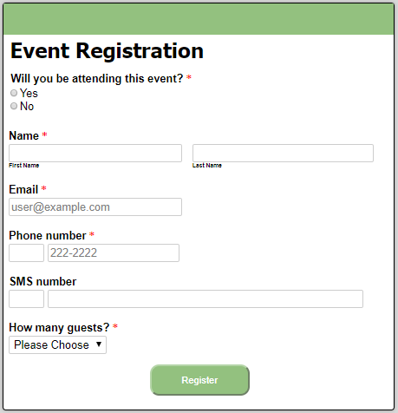

1. Create a custom class student and populate the following data by creating the collection of the student class.

The members in Student class are StudentId, StudentName, Age.

The list should contain nearly 5 records of student.

1. Using query syntax display the names of all students by writing LINQ query.
2. Write a LINQ query to return collection of anonymous types containing name and age.
3. Write a LINQ query to display details of all students whose age is greater than 12.
4. Write a LINQ query to display the oldest student from collection.